WIKI RELEASES DEBUT ALBUM

NO MOUNTAINS IN MANHATTAN OUT NOW VIA XL RECORDINGS
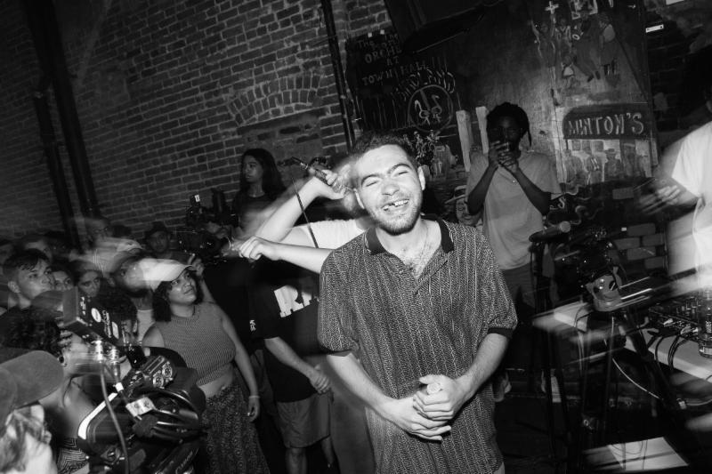
Wiki photo by Jessica Lehrman
LISTEN: No Mountains In Manhattan -

After sharing the video for new track "Mayor" two days ago, Wiki is back today to release his debut No Mountains in Manhattan. Out now via XL Recordings, the album features fellow New York natives, both legend and novice, including Ghostface Killah, Lakutis, ACAB, Slicky Boy, Your Old Droog and more. Production credits include Ratking's Sporting Life, Tony Seltzer, Kaytranada, Earl Sweatshirt, and Wiki himself.

Check out the album in full above now and see below for the "Mayor" video and more information about No Mountains In Manhattan.

WATCH: "Mayor" - http://youtu.be/o-ziihiGyFc

More about No Mountains in Manhattan:

No Mountains in Manhattan is a journey through the trials and tribulations of a coming to age experience in New York's most populated borough. Entirely crafted in XL's New York City studio, the album is New York to the core - featuring local emcees, from legend to novice. While Wiki's 2015 mixtape, Lil Me, was a snapshot into the youthful energy of an artist on the brink of adulthood, No Mountains in Manhattan finds the now 23-year-old artist facing his demons head on as he tackles topics such as addiction, relationships, identity, and responsibility. No Mountains in Manhattan is an introspective narrative of Wiki's life over the past year - a narrative that all young adults can relate to - a journey of peaks and valleys, of loss and gain, with a conclusion of understanding.

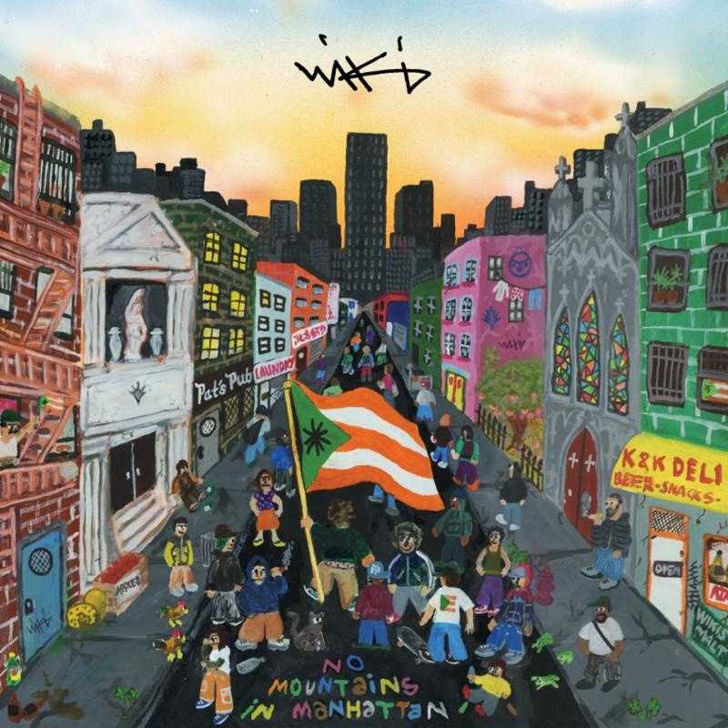
Wiki
No Mountains in Manhattan
XL Recordings
(August 25th, 2017)

1. Islander (produced by Alex Epton)
2. Mayor (produced by Tony Seltzer)
3. Pretty Bull (produced by Tony Seltzer)
4. Made For This ft. Ghostface Killah (produced by Tony Seltzer and Adrian Lau)
5. Chinatown Swing (produced by Sporting Life)
6. Litt 15 ft. Your Old Droog (produced by DJ Earl Teklife)
7. Face It (produced by Alex Epton and Sly C)
8. Stick Ball (produced by NOLIFE)
9. Elaine (produced by Wiki)
10. Pandora's Box ft. Evy Jane (produced by Dadras and Sporting Life)
11. Wiki New Written (produced by randomblackdude)
12. Jalo (produced by Black Mack)
13. Nutcrackers ft. Lakutis (produced by Wiki, Alon Sicherman and Alex Epton)
14. Baby Girl (produced by Kaytranada)
15. NMIM ft. ACAB, Slicky Boy (produced by Tony Seltzer)
16. Leppy Coqui

